**Directional Derivatives of Multivariable Functions**

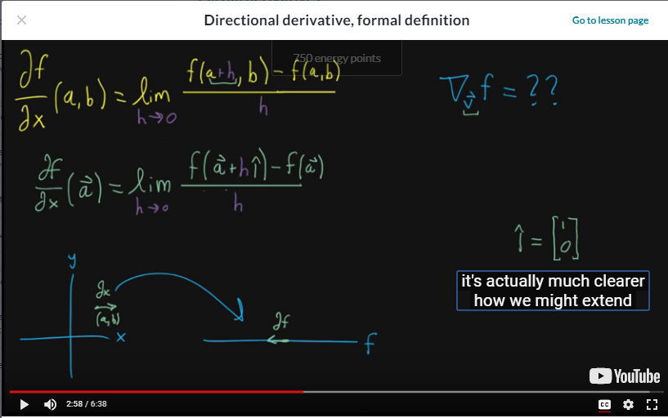

* Let’s start off with the formal definition of the partial derivative
  + We have our input space: X, Y Plane
  + And we think of it somehow mapping over to the real number line which is where your output f lives
  + Take partial derivative at some point (a,b)
    - We nudge it slightly in the X direction
    - See how that nudge influences the function
    - Size of nudge is dx and the impact on function as df
  + Think of h as the change in the input space
    - h is only changing the X component of the function
* Partial derivative rewritten (Moving towards directional derivatives, formal definition)
  + Same scenario as first partial derivative example
  + Instead of input of function f being (a,b) we notate the input as a two dimensional vector a
  + But now what do we add or how do we nudge vector a, in the previous example it was clear we could just add it to the first component (X component)
    - We add h times the unit vector in the X direction aka: i hat vector
  + Rewritten this way makes it much clearer how we can extend this idea to moving in different directions